00a- Meeting Minutes - Team

Part 1: Meeting information

Group Number | 12
Project Phase: | Sprint 1
Date/Time: | May 5, 10:00am
Type: | Team
Minute Taker: | Cole
Attendees: | Cole, Jonah, Abdullah, Nick, Kyle
Regrets: | None

Part 2 Notes:

- We finished sprint planning; epics are set up, everyone has their assignments, and we cleaned up duplicates; we’re treating epics as static for now mainly for tracking
- We agreed the report redesign deserves its own ticket; we’ll start UI ideas this sprint but leave full implementation until next sprint after getting client feedback
- For risk scoring, we aligned on assigning scores per answer using a simple scale; since we don’t have a client rubric yet, we’ll confirm with them or create our own baseline
- cFor the client meeting, we’re focusing on a few key points; scoring rubric, language requirements, and how detailed the report should be; we’ll also walk them through our current prototype
- We see AI as handling interpretation and explaining results in plain language; requirements are still unclear so we’ll keep pushing for more detail from the client

Part 3: Action Items
Owner | Task ID (existing or NEW) | Change / New Task Summary | Risk/Issue? (Y/N)  Risk ID | Status  (Open / Closed) | Screenshot of Trello Card(s)
Abdullah | New - #45 | New - Redesign report to make it more user friendly/readable? | N | Open | 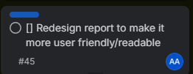
Nick/Jonah | New - #47 | New - Create Google Account for a shared Gemini API key | N | Open | 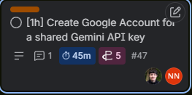
Nick/Jonah | New - #46 | New - Create list of all question tags in code under tags.ts | N | Open | 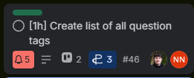
Nick/Jonah | New - #49 | New - Assign question tags from tags.ts to all questions in questions.ts | N | Open | 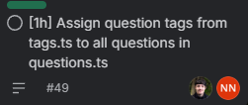

Part 1: Meeting information

Group Number | 12
Project Phase: | Sprint 1
Date/Time: | May 7, 10:00am
Type: | Team
Minute Taker: | Cole
Attendees: | Cole, Jonah, Abdullah, Nick
Regrets: | Kyle

Part 2 Notes:

Brief meeting where the team checked up on current tasks:
- Tasks for this sprint are mostly completed
- Minor reviews will take place today
- Preparing friday for deliverables and many meetings

Part 3: Action Items
Owner | Task ID (existing or NEW) | Change / New Task Summary | Risk/Issue? (Y/N)  Risk ID | Status  (Open / Closed) | Screenshot of Trello Card(s)

Part 1: Meeting information

Group Number | 12
Project Phase: | Sprint 1
Date/Time: | May 8, 12:00pm
Type: | Team
Minute Taker: | Cole
Attendees: | Cole, Jonah, Abdullah, Nick, Kyle
Regrets: | None

Part 2 Notes:

- We completed Sprint 1 with 45 out of 46 planned tasks finished, with only one ticket carrying into Sprint 2; the team also finalized the retrospective document and documented completed work with screenshots and tracked hours
- Sprint 2 planning focused mainly on translation support and report generation, including translating questions, UI text, and dynamic responses while also restructuring epics into user story format based on feedback
- We discussed the individual demo videos each team member needs to record, which will highlight personal contributions to the sprint and make up a significant portion of the sprint grade
- Presentation preparation is underway for Monday, with Cole taking responsibility for creating the slides and the team planning to divide presentation work more evenly in future sprints
- We reviewed remaining documentation tasks and deadlines, including meeting minute updates, sprint documentation, and integrating client feedback into new modular backlog tickets while keeping mobile-friendly design as a priority

Part 3: Action Items
Owner | Task ID (existing or NEW) | Change / New Task Summary | Risk/Issue? (Y/N)  Risk ID | Status  (Open / Closed) | Screenshot of Trello Card(s)
Cole | 30, 35, 44 | Changed tasks to user stories | N | Open | 